Press Release: somehow this relates to love
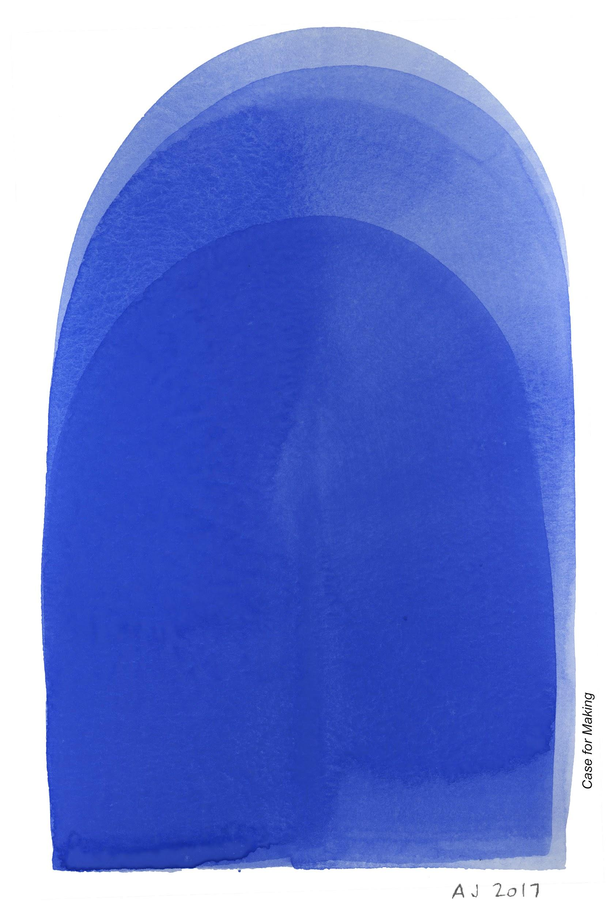

San Francisco, CA (January 2, 2019)

On January 24th, 2019 artist Lynn Marie Kirby will present work in the four alcoves of the Manresa Gallery inside St. Ignatius Church, on the campus of University of San Francisco, to continue explorations around missing tenderness that she and Sarah Bird began in a performative site intervention at the Venice Biennale of June 2017.

Giovanni Bellini’s Madonna and Child, painted 1480, was stolen from Madonna dell'Orto Church, Venice in 1993. For three days in June 2017 Kirby, in collaboration with Bird, enacted to hold to miss to remember. Bathed in a scent created for this project with Loreto Remsing of L’Aromatica, Kirby dressed as the missing Madonna, sat in one of two empty chairs installed outside of the church, and held participants. Kirby’s intention in wrapping her arm around strangers was to recreate the feeling of the tender gesture evoked by the missing painting.

In residence at St. Ignatius Church Kirby will make other attempts to recover the emotional heart of Bellini’s painting using video, sound, scent, touch, and performances using the motif of the Madonna and missing tenderness.

Kirby is working with the San Francisco Girls Chorus Level IV Ensemble to illuminate the relationship between mothers and daughters. The chorus is under the directorship of Valérie Sainte-Agathe and the performance will be conducted by Anne Hege, Level IV Director. Drawing from language provided by the girls themselves, Kirby collaborated with poet Denise Newman to write a libretto.The text is adapted into a composition by composer Jennifer Wilsey, with organ accompaniment by Will Johnson, and will be performed by the Chorus on January 24 and January 27.

Additionally, Kirby has been working with women at La Casa de las Madres, a local organization that provides intervention, support and shelter to victims and survivors of domestic violence. The outcome of these collaborations will be shown. Also exhibited will be banners and protest signs from Grannies Respond/Abuelas Responden, a group of grandmothers who travel together to the US southern border to protest the government’s family separation policy.

In Kirby’s words –

“Since the US Presidential election of 2016 there has been a growing inability in America to be present to one another, to listen. A lack of empathy for immigrants and refugees has made the vulnerability of women and children in our country particularly grave. As we examine the treatment of women and children in immigration and detention sites in an atmosphere of rising consciousness about the lack of power that women have had in this culture, a loss of tenderness could be said to define our moment. The Christian tradition venerates the Madonna in paintings and ceremony. My project creates a space for contemporary women and girls.”

Opening events for the exhibition will begin with a Long Distance Somersault performance by Judit Navratil and her daughter Luna Miyu Han, on Thursday, January 24th, 6:00 PM and Sunday, January 27th, 12:30 PM followed by the San Francisco Girls Chorus performance.

After the performance the audience will have the opportunity to engage with the rest of the exhibition, which will run through March 17th, 2019. Bitters made for this occasion by Maria Del Carmen Cortéz will be served at the opening reception. The drink, Xochitl Guadalupana, is made from plants that originated in Mexico.

Over the course of the exhibition there will be four Deep Listening® Sound Events open to the public in the alcoves. Deep Listening® is a meditative sound practice pioneered by the late composer Pauline Oliveros.

On view: January 24 - March 17, 2019
Openings: January 24 6:00 - 8:30 PM, January 27 12:30 - 3:00PM
Location: St. Ignatius Church, 650 Parker Ave, San Francisco, CA
Hours: Thursday/Friday 1:00 - 5:00 PM and Sunday 12:00 PM - 2:00 PM & by appointment: info@manresagallery.org
Admission: Free

Deep Listening® Sound Events over the course of the exhibit
Anna Wolfe-Pauly: Fridays, February 1 & 15 1:00 PM
Gabby Fluke-Mogul: Sundays, March 3 & 17 1:00 PM

PRESS CONTACT: Bonny Nahmias
Email: somehowthisrelatestolove@gmail.com
Phone: 415 678 0585
website: somehowthisrelatestolove.com
instagram: somehow_this_relates_to_love_

Press image credit: Alexis Joseph, Case for Making

Biographies of participating artists:

LYNN MARIE KIRBY is a San Francisco based artist. Her projects begin with a deep personal (which is also often a political) resonance, often inspired by relation to place or family.

For each project she develops a site related form through which to present collected material to the public. Her most recent work uses scent to explore expanded embodied perception.

Occupied with questions of place, the residue of history, and liminal states, Kirby’s practice depends on improvisation and collaboration, accidents that make her jump, and forms of contemplation.

Her background in cinema, performance, and sculpture, allows the work to rove between media, from film to video to web-based platforms and handheld devices, from screen to installation. The projects often include poetic and associative experimental text, in take away broadsheets or books that provide another dimension to the project.

In addition to the site embedded work of the last few years, Kirby’s work has been widely exhibited in galleries and museums, a selection from the last fifteen years includes: KADIST, Paris and San Francisco, 2017; Art in Embassies, Belgrade, Serbia, 2016; LACMA, Los Angeles, 2015; Fei Contemporary, Shanghai, 2014; Manresa Gallery, San Francisco, 2014; Museum of Modern Art, San Francisco, 2012; Brava Theater, San Francisco, 2012; Bio Paradis, Reykjavik, 2011; Berkeley Art Museum, 2011; Museum of Modern Art, New York, 2011; Wattis Institute, San Francisco, 2010; Getty, 2008; Art in Embassies, Chisinau, Moldova, 2007; Strasbourg Museum of Contemporary Art, 2017; Pompidou Centre, Paris, 2007; Manage Festival, St. Petersburg, 2006; Whitney Museum of American Art, New York, 2003; Yerba Buena Center for the Arts, San Francisco, 1999.

Kirby's films and videos have screened at festivals around the world, including Toronto, 2011; San Francisco, 2006; London, 1995; Athens. 1994; Oberhausen, 1990. She is the recipient of grants and fellowships from the San Francisco Arts Commission, 2014 and 2011; US State Department Art in Embassies, 2015 and 2011; Djerassi Rebecca Goldfarb Fellowship, 2007; Kelsey Street Press, 1999; Guggenheim Fellowship, 1998; California College of the Arts faculty development grants, 2013, 2012, 2011, 2008, 2006, 2004.

After studying in Paris, Stockholm, and Cambridge, Kirby received a BFA in Sculpture, 1977, followed by an MFA in Film, 1980, San Francisco Art Institute. She has an MFA in writing from California College of the Arts, 2016. Kirby is a Professor of Fine Arts and Film at California College of the Arts.

SARAH BIRD is an artist working in photography, sculpture and filmmaking. Her current work explores the relationships between humans and other beings in the natural world, in order to right the relationships in our web of being, to cultivate our capacities to care, and to catalyze us to protect earth’s precious biodiversity. This interest in relationship manifests in photographic and sculptural works about physical and time scale, currently taking the form of life-sized portraits of coast redwood trees. In Mapping Giants, a project in formation, Bird will photograph and print an entire coast redwood tree life size, and show it on a building in an urban environment. The conversation with the built environment serves to to bear witness to the trees’ magnificence and to their destruction.

She recently showed A Vision for Mapping Giants at CCA, an Affiliate Event of the 2018 Global Climate Action Summit, and in 2017 had a solo show the fullest measure of you, is you, at Chandra Cerrito Contemporary, and the site intervention to hold to miss to remember with collaborator Lynn Marie Kirby in Venice Italy during the 2017 Biennale. Bird has served as the Creative Director and Producer of Tippet Rise Art Center in Montana, directed a film exhibited at the Venice Architecture Biennale in 2016, co-wrote and produced the feature HairBrained (2014) and co-wrote The Oh in Ohio (2006). A dual US-Australia national, Sarah grew up in France, the UK, and the United States. She earned a BA from Amherst College and an MFA from California College of the Arts. She received Arts Corps Grant from the National Endowment for the Arts. She lives in Brooklyn, New York.

DENISE NEWMAN is a poet. Her collections include Future People, The New Make Believe, Wild Goods, and Human Forest. She is the translator of Azorno and The Painted Room, both by the late Danish poet Inger Christensen, and Baboon by Naja Marie Aidt, which won the 2015 PEN Translation Award. Newman is also involved in video, installation, and social practice projects that explore language and poetics, and for many years she has collaborated with composers providing lyrics for choral works and songs. She has received a Creative Work Fund Grant, and an NEA Fellowship in Translation. She teaches at the California College of the Arts.

JENNIFER WILSEY—composer, improviser, percussionist, and educator—creates listening spaces that invite expanding community through embodied presence. Her compositions interweave elements of text scores, graphic scores, conventional notation and field recordings. She often collaborates with other artists exploring relationships to environment and daily life. Jennifer has had performances of her works at leading venues in San Francisco, New York, and in Canada, and has received support from Meet the Composer, Inc., the Center for Deep Listening at Rensselaer, the National Endowment for the Arts, the Marin Headlands Center for the Arts, Dayton Hudson Fund, ARCO Foundation, The California Arts Council, The City of Los Angeles Cultural Affairs Department, and ARTS, Inc. Recordings of her works are available on the following labels: Deep Listening, Mutable, Cold Mountain Music, Public Eyesore Records, and Pitch-A-Tent. She is one of the core teachers of the Deep Listening® work of composer Pauline Oliveros, guiding large and small groups of participants from around the world via Deep Listening Retreats and Workshops, and the Deep Listening Online Certification Program through the Center for Deep Listening at Rensselaer. At Mills College, Jennifer directs the Musicianship Program, where she trains graduate students to work with undergraduate women in developing their musical voices, using both innovative and traditional pedagogical approaches. At Sonoma State University she directs the Percussion and Improvisation Ensemble, and teaches percussion and percussion pedagogy. Jennifer is the cofounder of several experimental ensembles, including Timeless Pulse (with Pauline Oliveros, Thomas Buckner, George Marsh, and David Wessel), and The Bloom (with W. Allaudin Mathieu and George Marsh). Jennifer’s projects have also included work with The Good Sound Band, Bernie Krause, Anna Halprin, Stuart Dempster, Gestaltish, The Luna Ensemble, and Petr Kotik and the SEM Ensemble, among others.

DR. ANNE K. HEGE is a San Francisco based composer, conductor, researcher, and vocalist. She began her musical studies singing with the Piedmont East Bay Children's Choir and the Oakland Youth Chorus’ touring ensemble Vocal Motion. In 2014, she completed her Ph.D. in Music Composition at Princeton University where she studied the use of embodied metaphor in multimedia works. She has founded and directed various vocal ensembles including the Albany Community Chorus (California), Cuatro Vientos (Mexico City), Celestial Mechanics (New Jersey), and Voci Women’s Vocal Ensemble (California). Hege performs as a vocalist, composer, and electronic musician in her performance duo New Prosthetics, the laptop ensemble Sideband, and in her own productions. She currently enjoys balancing her life as a voice instructor at Mills College, director of Level IV of the San Francisco Girls Chorus, a freelance composer, founder and director of the MAMA Residency, and mother of three wonderful daughters.

